**Lesson 1:**

The backside of this paper has a step-by-step drawing for you to create at home.

Materials

* Choice: Pencils, Pen, Crayons, Markers, Colored Pencils, paint.
* Blank Paper

Directions

1. Draw the picture step-by-step.
2. Be creative and add your own lines, shapes, and patterns to the paper.
3. If you have crayons, markers, colored pencils or even paint, color the picture.
4. If you have a phone or camera, take a picture of your work.
5. I want to hear from you. Send photo to my email: [jennifer.boyd@jcschools.us](mailto:jennifer.boyd@jcschools.us). I will reply with a comment and praise to any artwork that is sent to me.

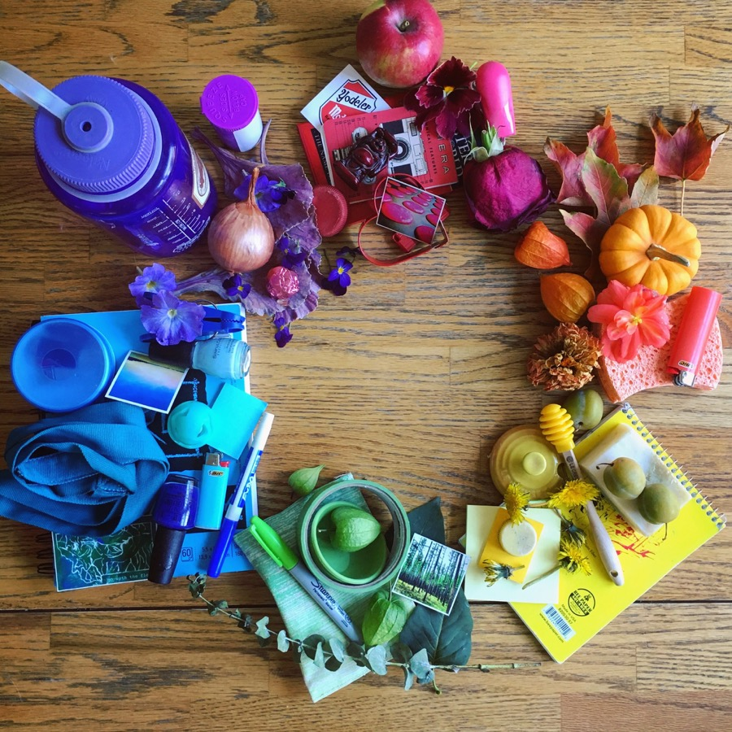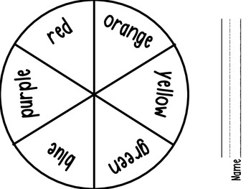**Lesson 2: Found Object Color Wheel.**

1. Find objects in the colors yellow, orange, red, green, blue and violet (purple).

2. Lay them out in color wheel order.

3. Take a photo: Send the photo to Mrs. Boyd at [jennifer.boyd@jcschools.us](mailto:jennifer.boyd@jcschools.us).